Dear Prof. Daniel,

Thank you for your valuable comments. I have considered them carefully and outlined the following plans for my next steps.

**1. Explained based on cloud base height**

A one-dimensional convective model based on four critical layers can be proposed (as shown in Figure 1): surface height, cloud base height (base), the 0°C level, and cloud top height (top). Precipitation can be divided into parts within cold clouds, warm clouds, and outside of clouds. The cloud base height (CBH) determines the cloud layer thickness. Liquid water increases above CBH through the cloud condensation process, while it decreases below CBH due to subsaturation. As illustrated in Figure 1a, the warm cloud layer in continental convection is relatively thin compared to monsoonal convection, resulting in a shorter vertical distance for cloud condensation and thus a smaller liquid water path. Therefore, incorporating CBH helps explain the differences in precipitation amounts.

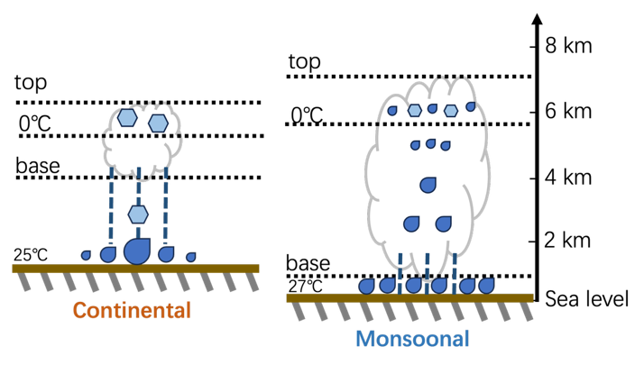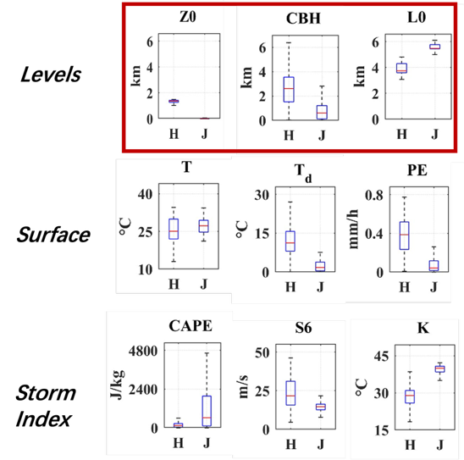

**Figure 1.** a) Conceptual cloud schematic map based on statistics of convective cloud and precipitation across regions. b) Three kinds of environmental parameters.

However, CBH alone cannot account for the differences in raindrop size and ice-phase precipitation. The relatively dry surface environment (Figure 1b) in continental regions may lead to lower raindrop concentrations, with little coalescence but more fragmentation, resulting in a higher number of small raindrops. Moreover, the melting of large ice particles such as hail forms large raindrops. The insufficient warm rain process fails to achieve the coalescence and fragmentation balance seen in monsoonal regions, which would produce a large number of medium-sized raindrops. These factors collectively contribute to the unique raindrop spectrum in continental convection. Regarding ice-phase precipitation, the thickness of ice clouds in the two regions appears similar in Figure 1a. However, continental convection produces more hail and large raindrops, indicating that extreme convection is more common in continental areas. This makes the storm indices particularly important for understanding these differences (Figure 1b). Nevertheless, the Convective Available Potential Energy (CAPE) is low, and the K index is small, suggesting a limited convective area. Only the deep wind shear is significant, which may be the key factor leading to extreme convection and hail production.

**Therefore, cloud layer structure, surface conditions, and storm indices (as shown in Figure 1b) are all vital in shaping the microphysical differences between continental and monsoonal convection.**

**2. Subsequent research plans**

Based on your suggestions, I have outlined the following directions for the next phase of my research:

1) Conduct a survey of previous studies on simulations to determine whether to run an ideal model or a real-case model.

2) Perform statistical analyses to assess how much of the variability in cloud base height and other properties (such as surface temperature, storm indices, etc.) can be explained.

3) Identify the key environmental properties and the mechanisms through which they influence convective microphysics across different climates.

These are the initial plans I have formulated for the next phase of my research. I will refine these plans further in the coming weeks.

Thank you again for your guidance. I will keep you updated on my progress.

Best regards,

Fan Bo